Becoming a Bioscientist 4:

Cell Biology Practicals

Overview
Mesenchymal stem cells (MSCs) are a population of multipotent cells found within many tissues of the body, including bone marrow. They are unspecialised cells that can differentiate into bone, cartilage and fat. Due to their ability to differentiate into other cell types, they are being explored for many clinical applications in tissue engineering and regenerative medicine. They also have other therapeutic properties including immunomodulation and providing trophic support through the secretion of paracrine factors. However, as you'll see in this project, not all MSCs are equal, and subsets within MSC populations may have varying therapeutic potential, for example differences in their potential to differentiate. Within one population there may be tripotent, bipotent, unipotent and nullipotent cells. Therefore, identifying specific subsets within a mixed population may help their development as a therapeutic.
Morphometric parameters such as cell shape and migratory capacity may be able to predict the differentiation capacity (potency) of an MSC subset. Over the semester you will perform a series of linked experiments that involve cell culture, fluorescence microscopy, image analysis and enzymology to evaluate whether cell shape and migration reflect MSC differentiation capacity. Lab practicals will be complemented with the analysis of big data sets obtained from time-lapse imaging of MSCs to determine whether there is a unique morphometric cell signature for different MSC subsets.
Together the teaching in this module will aim to address the following research question: Can cell shape and movement predict the capacity of an MSC to differentiate?

Learning Outcomes
By the end of these practicals, you should have:
- A theoretical understanding of basic in vitro cell culture.
- An appreciation of how to acquire and interpret fluorescence images of fixed cells.
- An understanding of how biochemical assays can be used to monitor stem cell phenotype.
- A case study to build a brief scientific report.

Assessment
The data you collect in these practicals will be used to create your scientific report and supporting information (RStudio project) which form the module assessment. For full details of the module assessments please visit the module VLE site.

Practical techniques

You should be familiar with
- Keeping a laboratory notebook*
- Accurate use of a micropipette*
- Using bright field and fluorescent microscopes*
- Measurement of change of a variable over time using appropriate equipment
* If you are unfamiliar with these techniques or need a refresher before the practical please visit the practical skills section of the skills hub on the VLE

You will learn in these practicals
- Fixing, staining, and mounting samples for fluorescence microscopy
- Assays to examine stem cell differentiation using enzyme activity and microscopy as read outs
- Use of a plate reader to measure absorbance of light.

Coordinating Instructions
- Your timetable will show which sessions you need to attend, there are several repeats for the microscopy sessions, please do not attend alternative sessions as each session has been designed based on room capacity.
- The practicals will take place in the Biology teaching labs. The Fluorescent Microscopy (FM) suite is on the first floor of T block, opposite lab 7.
- You should work in groups of 2-3.

Safety Information
- Collect your lab coat from your dedicated locker in the locker area
- Go directly to your workstation as instructed by a member of staff, put on your lab coat and safety glasses.
- Place any bags/coats in the cupboard nearest your workstation.
- You must not eat or drink whilst in the laboratory. This includes chewing gum. Other forms of hand-to-mouth contact must be avoided.
- Assign one part of your bench for writing materials etc. as a "clean" area, and the area as a "dirty" area.
- If you spill or break anything please report it to a member of staff. They will clean up.
- Anything that is dirty (slides, pipette tips etc.) should be placed into the appropriate jars, bags or trays for washing or disposal.
- Leave the lab when you have completed your work (and it is safe to do so) - take off your lab coat, safety glasses & wash your hands
- Return your lab coat to your dedicated locker in the locker area.
- You should follow Good Laboratory Practice (GLP) at all times.
Specific safety information relating to the chemical safety in individual practicals is included within each experimental section.

Experimental protocol – Practicals 1 and 2: Examining the morphology of different hMSC clonal lines

Overview of Practicals 1 - 2
Practicals 1 – 3 examine the morphology (size and shape) and actin cytoskeleton of different human MSCs (hMSC). You will test the hypothesis that hMSC clonal lines with varying potency to differentiate, may have different morphologies, potentially due to their differing roles in vivo.
To address this hypothesis, we will look at the size, shape and actin cytoskeleton of two different hMSC clonal lines (clone A and B, which have different differentiation potency), using fluorescent cell imaging. The cells were isolated from the bone marrow of a femoral head from a patient undergoing a hip replacement. The cells were immortalized by transducing them to express human telomerase, an enzyme which prevents the shortening of telomeres.
- In practical 1, you will fix, permeabilise and stain the actin cytoskeleton and nuclei of the cells using Phalloidin 594 and DAPI. The cells will be provided to you on glass cover slips and you’ll mount these on microscope slides for later imaging.
- In practical 2, you will use fluorescent microscopy to visualise the cells and capture images of the clonal lines.

– Cell fixation, staining and mounting

Overview of session 1
- You have been provided with a 24 – well tissue culture plate which contains the two hMSC clonal cells (Clone A and B) on glass coverslips
- In this session we will stain the actin cytoskeleton in the cells using Phalloidin conjugated to a fluorescent marker, and the cell nuclei using DAPI. Phalloidin binds to F-actin in the cell cytoskeleton and DAPI associates with double stranded DNA.
The following videos show aseptic technique and cell culture which was used to prepare the cells for you.
Aseptic Technique: Cell culture basics
Passaging Cells: Cell culture basics

Materials
Each group will be provided with:
- Stopwatches
- Microscope slides
- Mowial coverslip mountant containing DAPI (fluorescent DNA stain)
- Paraformaldehyde 4.0% (very toxic - wear gloves and eye protection, handle only in a fume cupboard, immediately report any spillage or skin contact/ingestion)
- Phalloidin 594 (very toxic - wear gloves and eye protection, handle with care, immediately report any spillage or skin contact/ingestion)
- 1% Phosphate buffered saline (PBS)
- 1% PBS + 0.1 % Triton-X100
- Fine forceps and a hypodermic needle (take care when handling needles, do not resheath needles and dispose of them and broken coverslips in sharps bins)

Cell fixation
Before we can visualise our cells, we need to “fix” them. Fixation is a critical step that terminates any ongoing biochemical reactions, increases the mechanical strength or stability of the cells, and prevents the cells from decay. We will fix our cells using a 4% Paraformaldehyde (PFA). PFA is diluted in PBS. Once in solution, formaldehyde is released. Formaldehyde cross-links primary amino acids to nearby nitrogen atoms in protein or DNA.
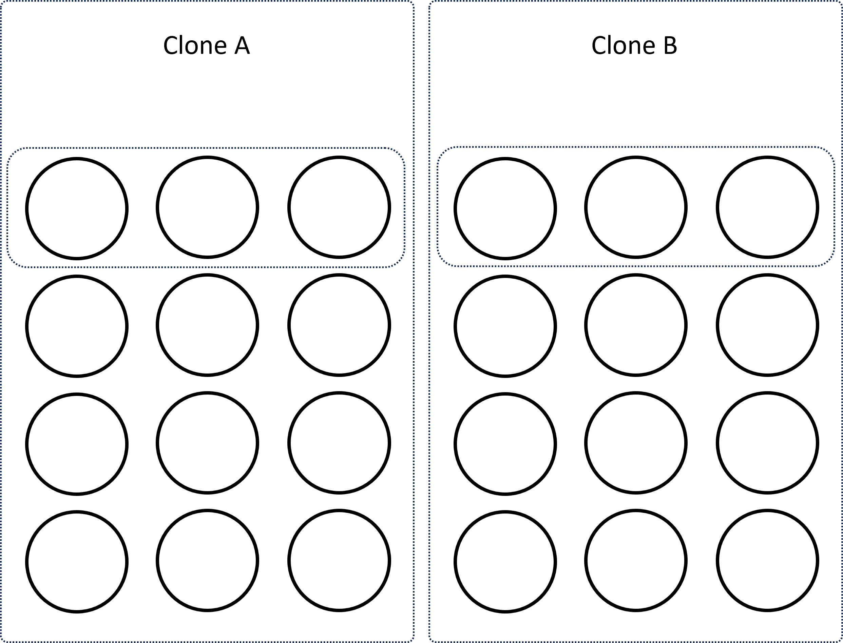
- Remove the cell culture media from the wells containing cells using a Pasteur pipette. This should be a total of 6 wells in the top row of the plate, 3 wells for each cell type.

Figure 1. Plate layout for each clonal line
- Add approximately 1 ml of PBS to each well and swirl the plate gently. Add the liquid carefully to each well to avoid detaching the delicate layer of cells that are on the glass coverslips.
- Remove PBS. 1 ml of PBS to each well and swirl the plate gently.
- Transfer plate to the fume cupboard.
- Remove the PBS. Add 0.5 ml PFA to each well.
- Incubate at room temperature for 15 minutes in the fume cupboard.
- Working in the fume cupboard, remove the PFA. Add 1 ml of PBS to each well. Swirl the plate gently and leave for at least 5 minutes on the bench.
- Working back on the bench. Remove PBS. Add 1 ml of PBS to each well. Swirl the plate gently and leave for 5 minutes on the bench

Cell permeabilization
To enable Phalloidin and DAPI to enter the cells, we must permeabilise the cell membrane. To achieve this, we use a detergent to create “holes” in the cell and nuclear membrane. We will use Triton X-100 (0.1% dilution in PBS) as our detergent. Triton does not affect the structure of the actin cytoskeleton.
- Remove PBS. Add 0.5 ml 1% PBS + 0.1% Triton X-100 to each well.
- Incubate at room temperature for 10 minutes on the bench.
- Remove the Triton. Add 1 ml of PBS to each well. Swirl the plate gently and leave for 5 minutes
- Remove PBS. Add 1 ml of PBS to each well. Swirl the plate gently and leave for 5 minutes

Cell staining

- Remove PBS. Add 200 μl/well of phalloidin 594 (diluted in PBS).
- Incubate at room temperature for 15 minutes on the bench. Cover your plate in tin foil to preserve the fluorophore.
- Remove the phalloidin. Add 1 ml of PBS to each well. Swirl the plate gently and leave for 5 minutes
- Remove PBS. Add 1 ml of PBS to each well. Swirl the plate gently and leave for 5 minutes
- Remove PBS. Add 1 ml of H₂O to each well.

Mounting
Once cells have been fixed and stained, the coverslips containing our cells are mounted onto microscope slides and can then be visualised. The mounting medium is the solution in which the specimen is embedded, generally under a cover glass. We will use a mounting solution called Mowiol. Mowiol hardens overnight after slide preparation ensuring that the coverslip remains in place. The Mowiol solution also contains DAPI for staining nuclei.

- Using forceps and a needle, gently remove the coverslips from their wells. The end of the needle has a small hook to it that you can use it to carefully lift the edge of the coverslip up from the base of the well. It is easiest to do this with your dominant hand. Hold the forceps in your non-dominant hand, and pick up the coverslip that you have lifted. The coverslips are delicate and can be broken easily.

Figure 2. Removing coverslips from wells using a hooked needle
- Place on a tissue CELL SIDE UP and air dry completely. Ensure coverslips are cell side up and the laid out in a way to enable you to distinguish which coverslips are from each cell line. The coverslips will take around 10 minutes to air dry, it is important there is no moisture left on the coverslip.
- Using a pencil label the frosted (white) part of one slide with your name and ‘Clone A’. Label a further slide with your name and ‘Clone B’.
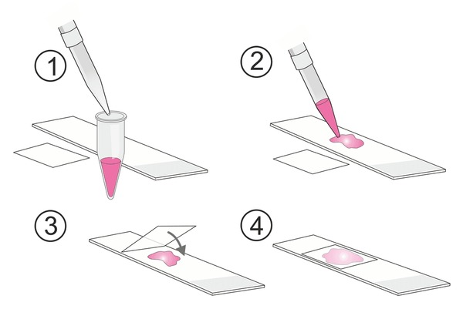
- Using a yellow tip, place a spot of Mowiol (~5 mm in diameter) onto a microscope slide. Leave space for another coverslip beneath on the slide as you’ll be mounting two coverslips on to each slide
Figure 3. Mounting coverslips onto microscope slides
- Using the forceps and needle, gently flip the coverslip over (ie. CELL SIDE DOWN) and lower onto the spot of Mowiol. If this is done carefully, there should be no air bubbles under the coverslip. Repeat for all the coverslips, mounting two on each slide.
- Your slides will be sealed with nail polish and stored in the fridge, protected from light.

Before you leave
- Tidy up your workstation and put away any unused or unwanted materials.
- Place all used reagent tubes in the ‘Used Tips’ pot
- Remove your lab coat and wash your hands before leaving

– Fluorescent Microscopy

Overview of practical 2
- In the past two practicals we seeded cells onto coverslips and then fixed, stained and mounted the cell-covered coverslips onto microscope slides in preparation for microscopy.
- We stained the actin cytoskeleton of the cells using Phalloidin conjugated to a fluorescent marker (Texas Red), and the cell nuclei using DAPI. Phalloidin binds to F-actin in the cell cytoskeleton and DAPI associates with double stranded DNA.
- We can use a fluorescence microscope to visualise the fluorophores and capture images. We need to capture images of the two fluorophores individually, we’ll then use the microscope software to overlay the images together and add a scale bar.

How to use the Leica DMIL inverted fluorescence microscope.
You are already familiar with the basic operation of a compound microscope however the fluorescent microscope (Figure 3) appears slightly different as it is inverted (you look at the sample from below), it has fluorescence attachments and is connected to a camera which feeds the image to a computer. There are some key operational differences.
- There is a slider on the RHS close to the eyepieces to direct light to either the eyepiece or the camera.
- There is a separate control for the light source used in fluorescence mode (small white control panel on the desk labelled CoolLED).
- Beneath the stage there is a slider containing a series of filter sets with excitation and emission filters for different fluorophores.
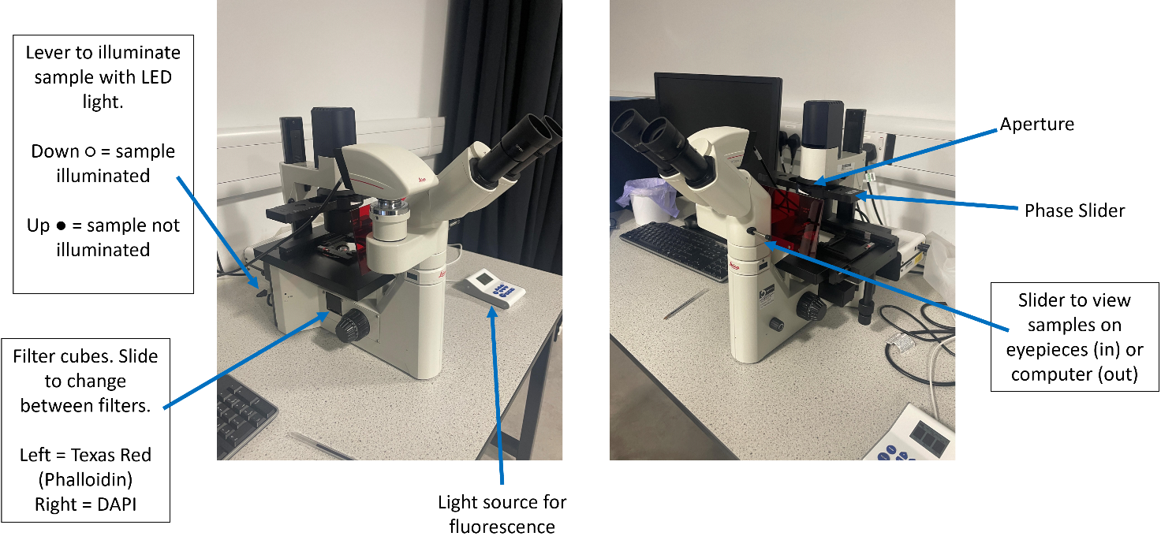
Before starting, spend a bit of time familiarising yourself with the controls and where they are located.
Figure 4. LEICA DMIL LED Fluorescent microscope

Operating the microscope in fluorescence mode
When carrying out fluorescent imaging close the aperture (above phase slider) and switch on the LED light source by using the white CoolLED control pad. The CoolLED control pad has three settings for different wavelength light sources. All 3 channels should be set to 100 %.
The microscope is set up with three filter sets that have the correct excitation and emission filters for particular fluorophores. The filter sets are on a filter cube slider under the objective lenses. The correct filter set for the samples you are working with should be moved into the light path. (Left for TexasRed (Phalloidin), right for DAPI).
There is a lever at the rear LHS of the microscope (labelled stop) to allow the fluorescence light source to illuminate the sample (Up for Off and down for ON). Turn off the illumination when you aren’t viewing your slides as the fluorophores on your cells are sensitive and can bleach.
The microscope has 10x, 20x, 40x phase and 100x oil objectives. These are below the stage. You can change between them by carefully rotating the unit they are attached to. The phase slider is at the top of the microscope and should be adjusted to match the objective you are using (to either 10/20 for 10x and 20x objectives, 40 for the 40x objective or the empty slot for 100X)
There is the option to view the image through the eye pieces or via camera. This is controlled by a slider on the RHS just below the eye pieces. It should be pushed in to view through the eye pieces and out for the camera.
      - Place a slide on the stage upside down (with the cover slip closest to the objective). Hold the slide at it edges and avoid touching the coverslips as the mountant has not set.
      - Start by viewing your cells using the 10x objective, adjusting the phase slider to the 10/20 position.
      - Slide the filter cube to the DAPI filters (RHS).
      - Illuminate your sample by adjusting lever to the On position (down)
      - View your cells down the microscope, the slider beneath the eyepieces should be pushed all the way in.
      - Focus the objective to visualise the cell nuclei (stained in blue with DAPI).
      - To capture the best image change to the 40x objective (change phase slider to 40) and refocus on the cell nuclei.
      - Turn off the illumination to protect the fluorophores by adjusting the level to the off position (Up).

Acquiring and manipulating images
The fluorescence microscope is designed to work in conjunction with image capture software. This software enables you to take single or multiple images of the same area of a slide using different microscope settings (e.g. different filters). Images can then be “stacked” to produce composite images. The software does not control the microscope, but it is important that the settings in the programme match the settings on the microscope.
            - Log on to the computer. The username is User and there is no password.
            - Open the LAS AF software from the desktop (The Leica AF Hardware Configurator icon on the desktop is the microscope settings – don’t touch!). As the program loads you will be asked to set the configuration. The default is “DefaultDynamicWidefieldTree.xlhw” and “Standard Configuration”. The programme opens with the “Acquire” section automatically opened (Highlighted red on top of screen).
            - There are three “panes” on the screen. The left pane is the Experiments and Acquisition pane which has two tabs “Experiments” and “Acquisition”.
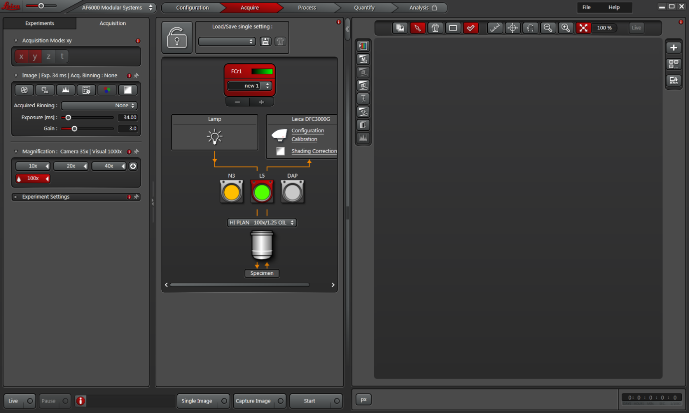
Figure 5. LAS AF Software
            - The Experiments tab is where images are stored. At the bottom of the window you can un-tick the ’Use Default Image Base Name’ box and use your own name.
            - The Acquisition tab allows you select the objective you want to use. It is important that you tell the software which objective you are using as this allows the software to calculate the magnification for things like measuring and scale bars.
            - Select the 40x objective in the magnification panel.
            - The Middle pane allows you to select which filter cube you want to use (Figure 5). To do this click onto the cube you require so that it is highlighted in red. As we are beginning with DAPI, select the RHS filter cube labelled “DAP”. Make sure that “DAPI” is selected from the Fluorescence channel dropdown menu in the box labelled “FCr1”.
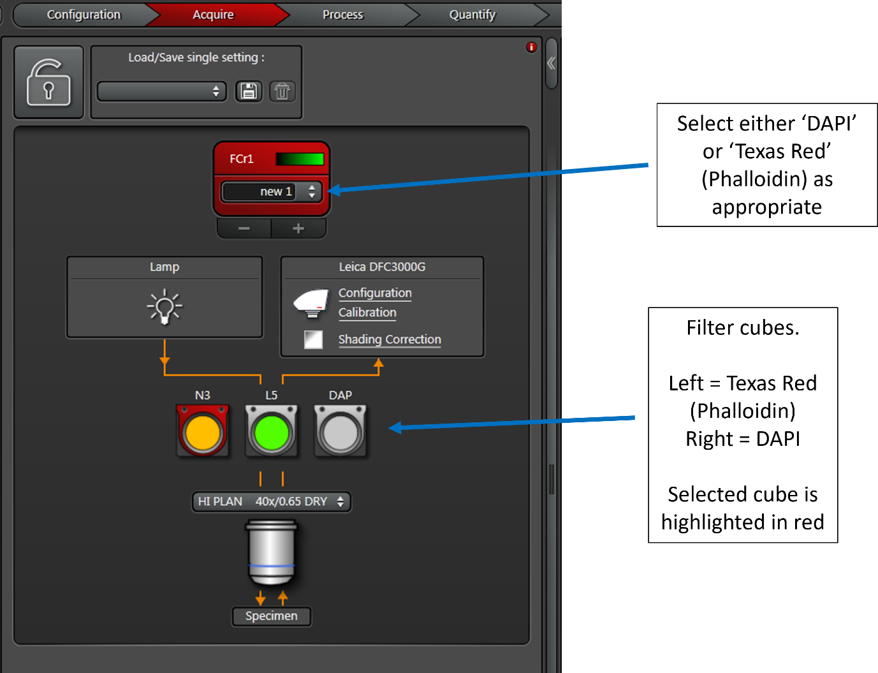

Figure 6. LAS AF Software Middle Pane showing setting for filter cubes
            - The right-hand pane is where the image that you are working with is presented. To see what is currently being viewed down the microscope click ‘Live’ at the bottom left hand corner for a live image. You’ll need to make sure the slider below the eye pieces is pulled out, and that the sample is illuminated (lever on the LHS of the microscope).
            - Adjust exposure and gain in the acquisition pane to alter any over- or underexposure of your fluorophores. A member of staff or demonstrator can help you with this.
            - To view the actin cytoskeleton staining, change the filter cube to the LHS to Texas Red. In the software, make sure the “N3” filter cube in the middle pane is selected, and fluorescence channel “Texas Red” is selected from the dropdown menu in the box labelled “FCr1”. You may need to turn “Live” off and on again for the settings to apply.

Acquiring and manipulating images
When you have set up the microscope and software to the correct settings you can then capture an image.
      - To capture an image, click ‘Single Image’ at the bottom of the screen. Each image is given a unique number and is listed in the Experiment Tab. Right-click on the image you have just taken and rename it stating the cell clone and fluorophore imaged. You may want to note the Gain and Exposure settings used for each channel, as these may be lost when changing other settings.
      - Without moving the location of the slide on the stage, capture an image of both the DAPI and phalloidin stains. You may need to adjust the focus between settings, but do not change the position of the slide.
      - To overlay the images, select the DAPI and phalloidin images in the experiment tab, right click, and select “overlay”. In the right-hand tab, select “Overlay”. The overlay image will appear in the Experiments tab. Rename the image as appropriate.
To export images right click on the image name in the Experiments tab and export them as Tiff or JPEG files.
To add a scale bar to your image select ‘Micron scale’ from the “add quick annotations” menu. You can change the setting but the default settings are fine.
You should save the images in a folder with your usernames inside the ‘BIO00066I Cell Biology’ folder on the computer desktop. The images will be added to the VLE for you to access. If you don’t export the images they will be lost when the software is shut down.
During the practical capture images of both cell lines to best represent the differences you can observe between them.

- Measuring Osteogenesis in hMSCs

Overview of Practical 3
To measure the differentiation potential (potency) of clonal lines A and B, we are going to assess their osteogenic potency (ability to differentiate into or towards osteoblasts). To induce osteogenesis in-vitro MSCs are plated at 100% confluence (no gaps between cells) and cultured with an inductive media of dexamethasone, β-glycerophosphate and L-ascorbic acid 2-phosphate. Dexamethasone (dex) is a hormone with stimulates RUNX2 an osteogenic transcription factor, whilst β-glycerophosphate (β-gly) and L-ascorbic acid 2-phosphate (L-asc) provide cells with the factors required to provide a collagen I and mineralised matrix.
During the early stages of osteogenic differentiation when MSCs begin to slow in proliferation, produce a collagen and calcium phosphate matrix and become osteoblasts they produce greater quantities of the enzyme alkaline phosphatase. As differentiation assays take several days and media changes, the osteogenic differentiation has already been performed for you, and you are provided with cell lysates (liquid contents of cells broken apart) from control and osteogenic samples from the two different clonal lines at different time points.
The data that you collect in this practical should be used to replace the sample data you worked on in Data Analysis Workshop 4.

Osteogenic differentiation
The following osteogenic differentiation protocol was used to obtain the cell lysates you are analysing;
Day -1: Clonal lines A and B were plated at confluence and left for 24 hours.
Day 0: Fresh media was added to all conditions, either basal media for controls or media supplemented with dex, β-gly and L-asc for osteogenic conditions. Day 0 samples were lysed for clonal lines A and B (control only as osteogenesis has not been induced in any samples at this stage).
Day 8: Control and osteogenic samples were lysed for clonal lines A and B.

Assessing osteogenesis by measuring alkaline phosphatase activity
Alkaline phosphatase (AP) is an enzyme that catalyses the hydrolysis of phosphate esters into inorganic phosphates (Figure 6).

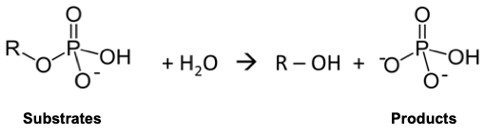
Figure 7 Reaction catalysed by Alkaline phosphatase
The activity of alkaline phosphatase can be determined by following either the disappearance of substrate or the appearance of products. Here we will monitor the formation of a product. The assay uses p-nitrophenyl phosphate (pNPP) as the substrate which alkaline phosphatase converts to p-nitrophenol (pNP) and has a distinctive yellow colour (Figure 7). This is measured colorimetrically using a plate reader with a filter set at 405 nm. The product, p-nitrophenol has an absorbance maximum at 400 nm.
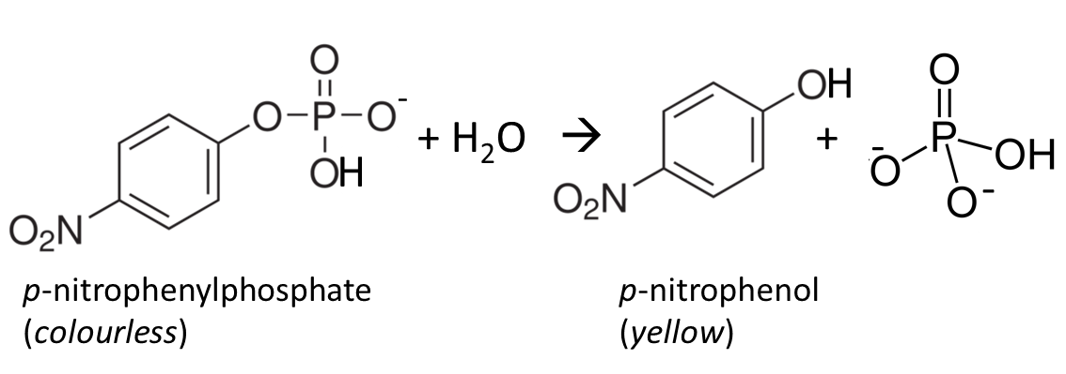
Figure 8 Conversion of p-nitrophenyl phosphate to p-nitrophenol by alkaline phosphatase
To assess the quantity of alkaline phosphatase in the clonal lines, we can measure its activity by incubating cell lysate from either control or osteogenic conditions with p-nitrophenyl phosphate.

Materials
Each group will be provided with:
- Calculator
- 10 mM stock solution of p-nitrophenol (pNP)
- 0.2 M carbonate buffer, pH 10.2
- P1000, P100 and P20 Gilson pipettes with tips
- 1.5 mL Eppendorfs
- Marker pen
- 96 well plate
- 200 ul of cell lysate for each experimental condition
- Stopwatch

Prepare pNP standards to create a standard curve
To determine the amount of product (pNP) produced by alkaline phosphatase (and therefore enzyme activity) in the cell lysates we need to create a standard curve. We do this by measuring the absorbance for known values (standards) of pNP. From this data we can create a standard curve of pNP concentration vs absorbance and determine the concentration of pNP in the cell lysates. To do this we’ll dilute a stock solution of pNP (10 mM) to create our standards of known concentrations.
            - For each standard (concentrations detailed in the table below) you’ll prepare 800 ul.
            - Label 8 Eppendorf tubes with the concentrations of the pNP standards you are preparing.
            - For the highest concentrations (0.5, 0.3 and 0.2 mM pNP) you first need to calculate the correct amount of pNP stock solution to dilute in carbonate buffer to get the correct concentration. You should check your workings with a member of staff or a demonstrator.

You can use the following relationship to determine how much pNP stock solution to dilute in carbonate buffer:
C_{initial} x V_{initial =} C_{final} x V_{final}
Where;
C = concentration,
V = volume,
initial = starting value (e.g. 10 mM for the initial concentration of the stock pNP)
final = end value (e.g. 400 μl for the final volume of the standards)
pNP standard concentration (mM) | pNP (μl) | 0.2M carbonate buffer (μl) to make a total of 800 μl
0.5
0.3
0.2
0.1 | Prepare by serial dilution of 0.2 mM standard | 400
0.05 | Prepare by serial dilution of 0.1 mM standard | 400
0.025 | Prepare by serial dilution of 0.05 mM standard | 400
0.0125 | Prepare by serial dilution of 0.025 mM standard | 400
0 | 0 | 800

- Prepare the 0.5 mM, 0.3 mM and 0.2 mM standards and mix carefully.
- As the standards of 0.2 mM and below are half of the concentration of the standard beforehand, they can be created by a serial dilution of each other. This is more accurate than making up the standards individually. To prepare for the serial dilution, add 400 μl of buffer to the eppendorfs labelled 0.1, 0.05, 0.025, 0.125 mM.
For example, to make the 0.1 mM solution, take 400 μl of the 0.2 mM standard and add it to 400 μl of buffer. Mix carefully by pipetting the standard up and down.
The 0.05 mM standard can then be made by taking 400 μl from the 0.1 mM standard and adding it to 400 μl of buffer. This process is then repeated to make the 0.025 and 0.0125 mM standards.
- Transfer 100 μl of each standard to a labelled 96 well plate in triplicate. An example plate layout is shown in Figure 8. Your labelling does not need to be as detailed as the figure is, you just need to know what is in each part of the plate.

 | 1 | 2 | 3 | 4 | 5 | 6 | 7 | 8 | 9 | 10 | 11 | 12
A | 0.5 mM pNP standard | 0.2 mM pNP standard | 0.05 mM pNP standard | 0.0125 mM pNP standard |  | Day 0 Clone A | Day 8 Clone A | Day 8 Clone A Osteo
B | 0.5 mM pNP standard | 0.2 mM pNP standard | 0.05 mM pNP standard | 0.0125 mM pNP standard |  | Day 0 Clone A | Day 8 Clone A | Day 8 Clone A Osteo
C | 0.5 mM pNP standard | 0.2 mM pNP standard | 0.05 mM pNP standard | 0.0125 mM pNP standard |  | Day 0 Clone A | Day 8 Clone A | Day 8 Clone A Osteo
D | 0.3 mM pNP standard | 0.1 mM pNP standard | 0.025 mM pNP standard | 0 mM pNP standard |  | Day 0 Clone B | Day 8 Clone B | Day 8 Clone B Osteo
E | 0.3 mM pNP standard | 0.1 mM pNP standard | 0.025 mM pNP standard | 0 mM pNP standard |  | Day 0 Clone B | Day 8 Clone B | Day 8 Clone B Osteo
F | 0.3 mM pNP standard | 0.1 mM pNP standard | 0.025 mM pNP standard | 0 mM pNP standard |  | Day 0 Clone B | Day 8 Clone B | Day 8 Clone B Osteo
G
H

Figure 9 Example plate layout

Aliquot cell lysates into plate
      - You have been provided with the following cell lysates;

- Day 0 Clone A Control
- Day 0 Clone B Control
- Day 8 Clone A Control
- Day 8 Clone B Control
- Day 8 Clone A grown in osteogenic media
- Day 8 Clone B grown in osteogenic media

      - Aliquot 50 µl of each lysate into the 96 well plate in triplicate. An example plate layout is shown in Figure 8.

Addition of pNPP substrate to cell lysates
            - Once you have plated out your standard curve and cell lysates a member of staff or demonstrator will add 50 μl of the pNPP substrate into each sample of cell lysate using a multichannel pipette. We are using a multichannel to ensure the substrate is added to all lysates at almost the same time.
            - Incubate your plate for 30 - 50 minutes at 37 ºC in the temperature controlled room.

Measure absorbance using the plate reader
      - Your plate is ready to measure on the plate reader when some of the lysates (I won’t say which to save the surprise!) appear yellow in colour.
      - Take your plate to one of the plate readers to measure the absorbance of all wells at 405 nm.

Data Analysis
Data workshop 4 demonstrates how to create a standard curve from sample data of pNP concentrations. You should edit the template excel file you used in the workshop to include the data you collected in this practical to plot a standard curve from your own data and determine the pNP concentration in the cell lysates.
The workshop also taught you how to normalise your results (calculate pNP concentration and therefore ALP activity relative to cell number) as during differentiation the number of cells in each sample will vary, and without normalisation you cannot determine if the increase in ALP activity is the result of higher enzyme activity or simply a greater number of cells producing the same amount of ALP. To normalise the data you need to divide the concentration of pNP in each sample by the concentration of DNA in each sample. You also need to edit the DNA concentration in the template excel file from the data analysis workshop with the PicoGreen Dataset – DNA concentration per sample that I have collected for you from the same cell lysates you used in this practical. This will be available on the VLE shortly after the practical.
If you are not confident in the results you have obtained from this practical you can use sample data collected by a demonstrator in the same practical that will be shared on the VLE. You should use this sample data for both the standard curve and the lysates as they were collected at the same time using the same plate reader.

